Rector’s Report October 2024

- On Wednesday September 25, I met with the Confirmands for dinner to prepare for the Bishop’s Visit. The Confirmands were excited that they were getting confirmed, received, and reaffirmed a couple days before the Feast Day of St. Teresa of Avila, October 15. At their Confirmation, they each received copies of Teresa of Avila’s Interior Castle, translated by Mirabai Starr. We are talking about reading the book together in January and February, meeting on Thursday nights at 6:30 PM, starting January 9.

- On Thursday October 3, Pastor Karen Stanley began her Bible Study series on the Gospel of Luke, which has been well attended. That afternoon, I visited Deacon Anne Pierson who was in good spirits and is on her way to remission and recovery.

- On Friday October 4, Bishop Megan arrived in Humboldt County and met with the Clericus for dinner at Deacon Cindy Woods’ home.
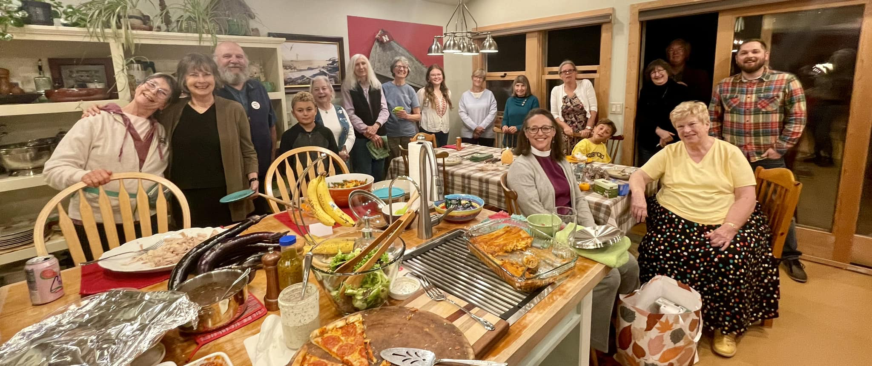
- On Saturday October 5, Bishop Megan joined us for her first Sacred Saunter at Sequoia Park, which included the annual St. Francis Blessing of the Animals.

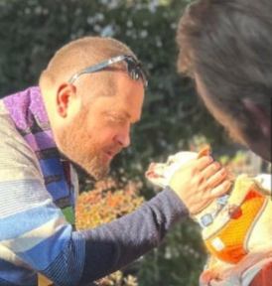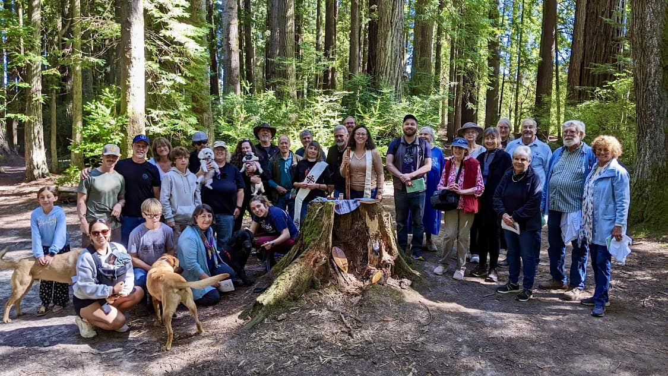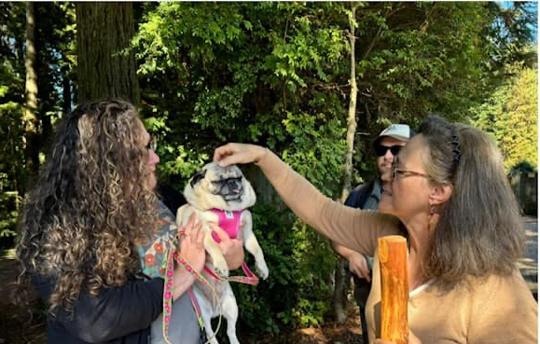

- On Sunday October 6, we blessed animals in the Sts. Martha and Mary Courtyard during Joy Mass, which resumed on September 29, Michaelmas.

- On Tuesday October 8, Bishop Megan, Heidi Erickson, and I visited Humboldt Domestic Violence Services and toured their facility, which we rent to them at below-market price. We met with the Executive Assistant Amber Pegg and Executive Director Emely Fuentes-Neilson.

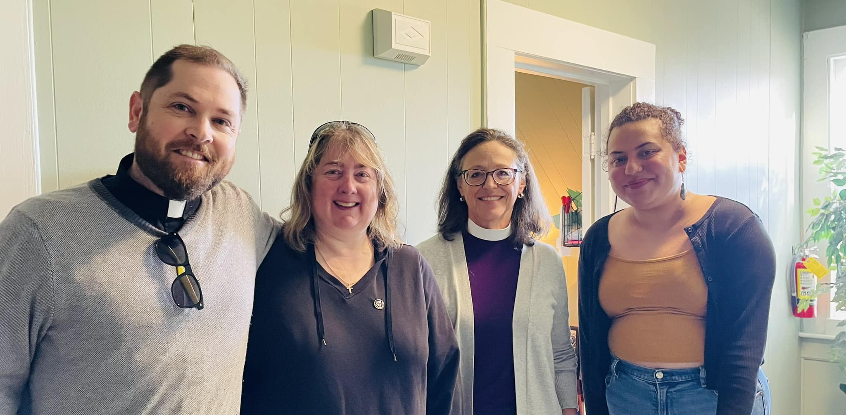
- On Friday evening October 11 (Yom Kippur) , I attended the Kol Nidre service at Temple Beth El. I invited Rabbi Naomi Steinberg to guest preach at Christ Church on Sunday January 26, 2025 and she agreed to do so. And I invited Rabbi Bob Rottenberg to guest preach on Sunday June 22, 2025…

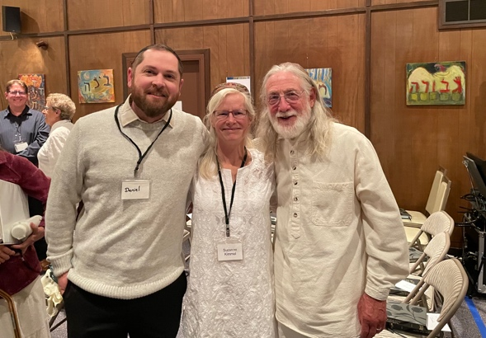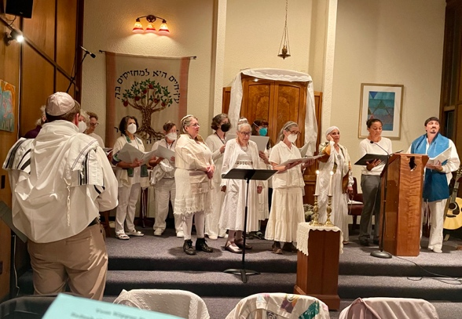

- On Saturday October 12, Christ Church hosted the Semper Virens deanery Convocation, which featured the presence of our bishop! Although Steve Preston and Daniel Hafer attended via zoom, several other elected delegates of Christ Church did not show up. Now that we have six delegates to be sent to Diocesan Convention, we need to make sure that those who run for this position make it a priority to attend both Convocation and Convention. Robin Cardona and Steve Preston are the only elected delegates who will continue to serve this year. Everyone else had to be replaced: Heidi Erickson will be replacing Catherine Mace (who should not run for delegate again); Paul Gossard will be replacing Roni Carlson; and Elizabeth Harper-Lawson will be replacing Daniel Hafer. We currently have no alternates.

- On Sunday October 13, Bishop Megan preached and presided at the 8 AM, 9:30 AM and 10:30 AM services, confirming Leslie Allen, Harry Wells, Sheena Ruchte, and Linnea Hill; receiving Ava Bennett, Lisa Bennett, and Carrie Moses; and reaffirming Kathy Clague. At 12:30 PM, the bishop met with the vestry in the Pierson Room.
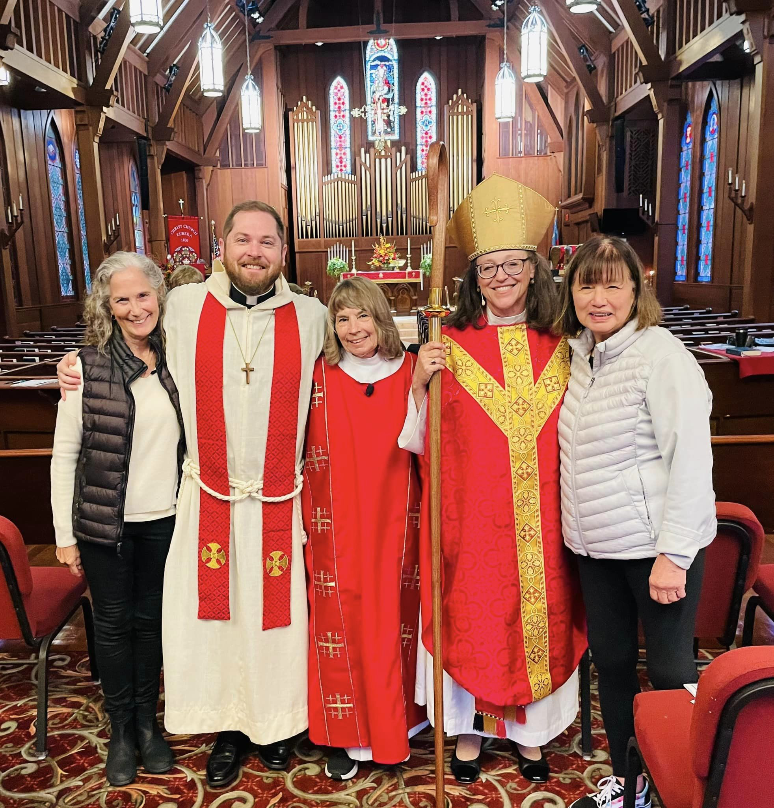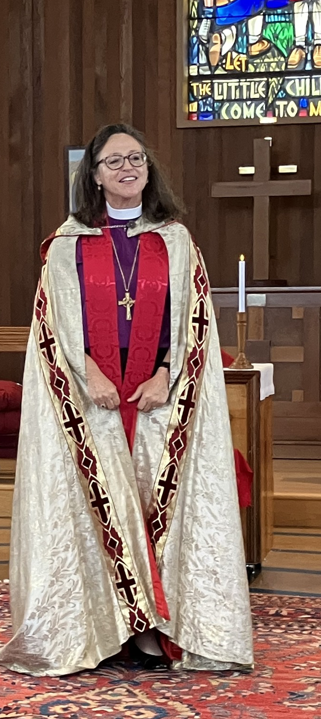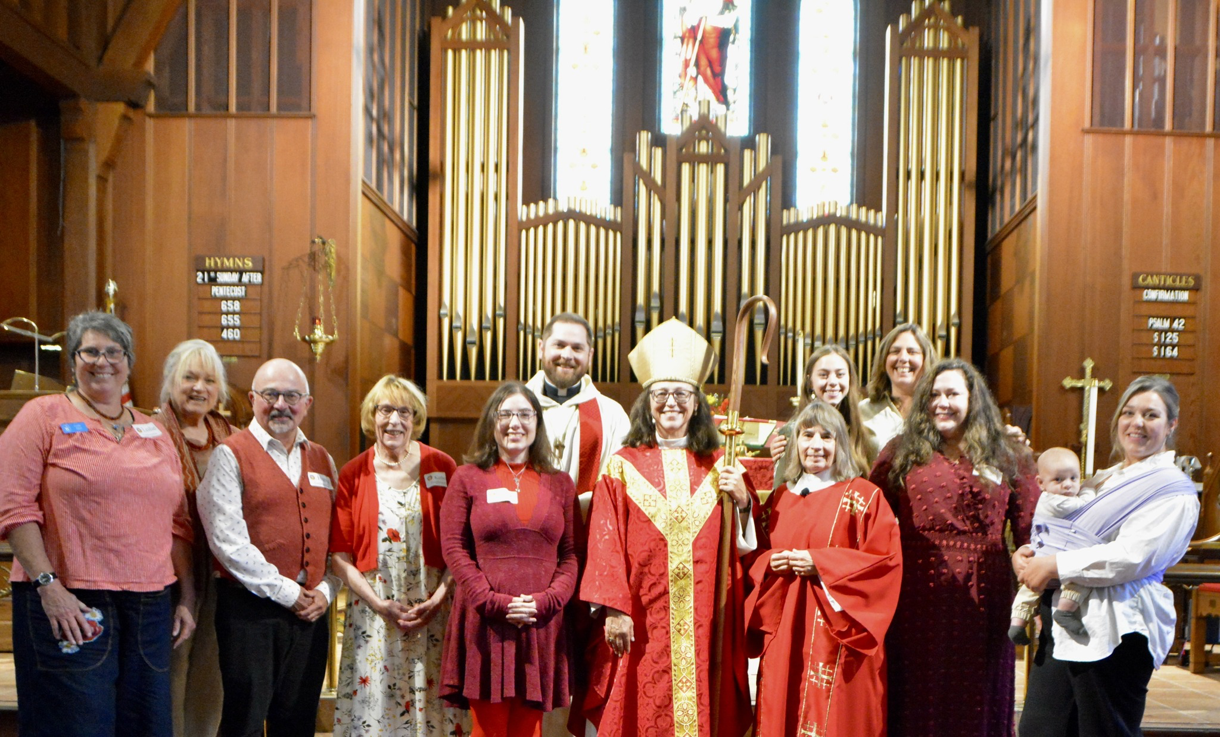

- On Friday October 18, I dropped off 70 lbs of Transfiguration House pears at Food for People. More to come!
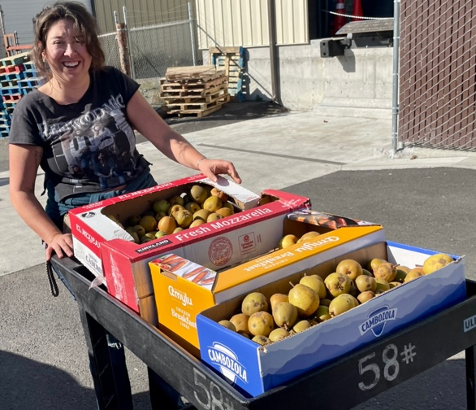
- On Friday evening October 18, I attended the Humboldt County Children Author’s Festival Banquet at the Sequoia Conference Center. Christ Church is a sponsor of this weekend-long event and this year they were celebrating their 50th Birthday. I sat at a table with Christ Church parishioners and Children’s Author Bob Barner.

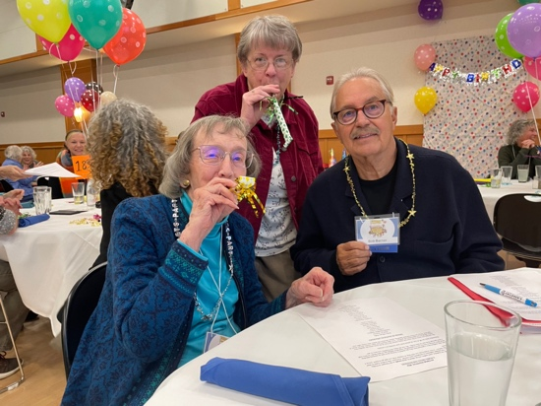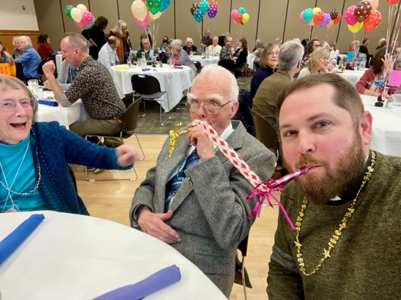

- On Saturday October 19, I bought books at the library including a book by Bob Barner on El Dia de Los Muertos and Natasha Wing’s Jalapeño Bagels, which she signed. Later, I attended the Donor Appreciation Party at Food for People and was given a tour of their new facility. I also met the new Food Bank Executive Director Carly Robbins.
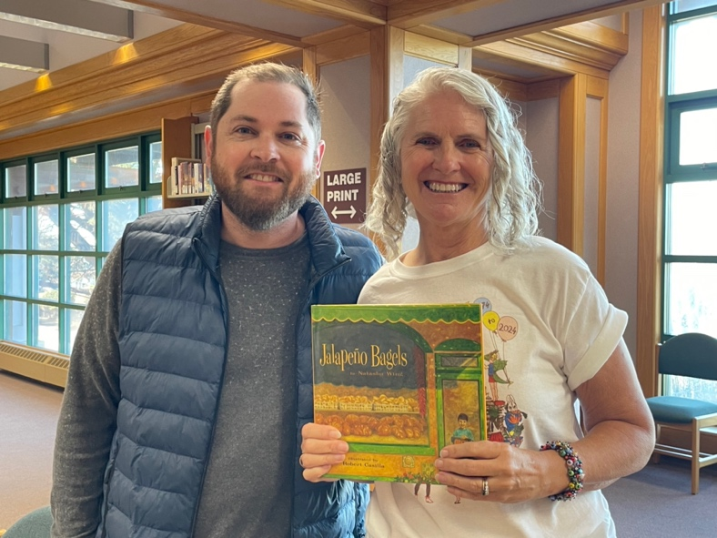
- On Saturday evening October 19, I participated in the Labyrinth Walk, which concluded with a brief “Liturgy on the Labyrinth,” which was essentially the Liturgy of the Word for Sunday. The attendance for this service and other future services like it (on Saturday evenings) are to be included in the Average Sunday Attendance.

- On Sunday evening October 20, while meeting with Steve Preston at the Village Pantry, I connected with David S. and paid for him to have a night at the Motel 6.

