Rector’s Report April 2023 (submitted April 23)

- On Thursday March 30, the Sacred Ground circle met in person at Christ Church for our eleventh and final session. During this final meeting, we discussed what our journey after Sacred Ground might look like individually, as a parish, and in the wider community. As a reminder, Sacred Ground is a film- and readings-based dialogue series on race, grounded in faith. The Diocese expects all lay leaders to participate in Sacred Ground (or in a comparable program). https://www.episcopalchurch.org/sacred-ground/

- On Saturday April 1, a total of 27 people attended our Sacred Saunter Outdoor Eucharist at Sequoia Park, including Cal Poly Humboldt Religious Studies lecturer Stephanie Corigliano who brought along nine Cal Poly Humboldt students. They began their Experiential Workshop on Liturgy and Charisma in Christianity with our worship service. The workshop also included visits to St. Innocent Orthodox Church, Faith Center, St. Mary’s Catholic Church, Arcata United Methodist, and LifeHouse Arcata. On the Saunter, we celebrated the Feast Day of influential Anglican theologian Frederick Denison Maurice (1805 – 1872): https://deforestlondon.wordpress.com/2023/04/01/sauntering-and-listening-with-f-d-maurice/

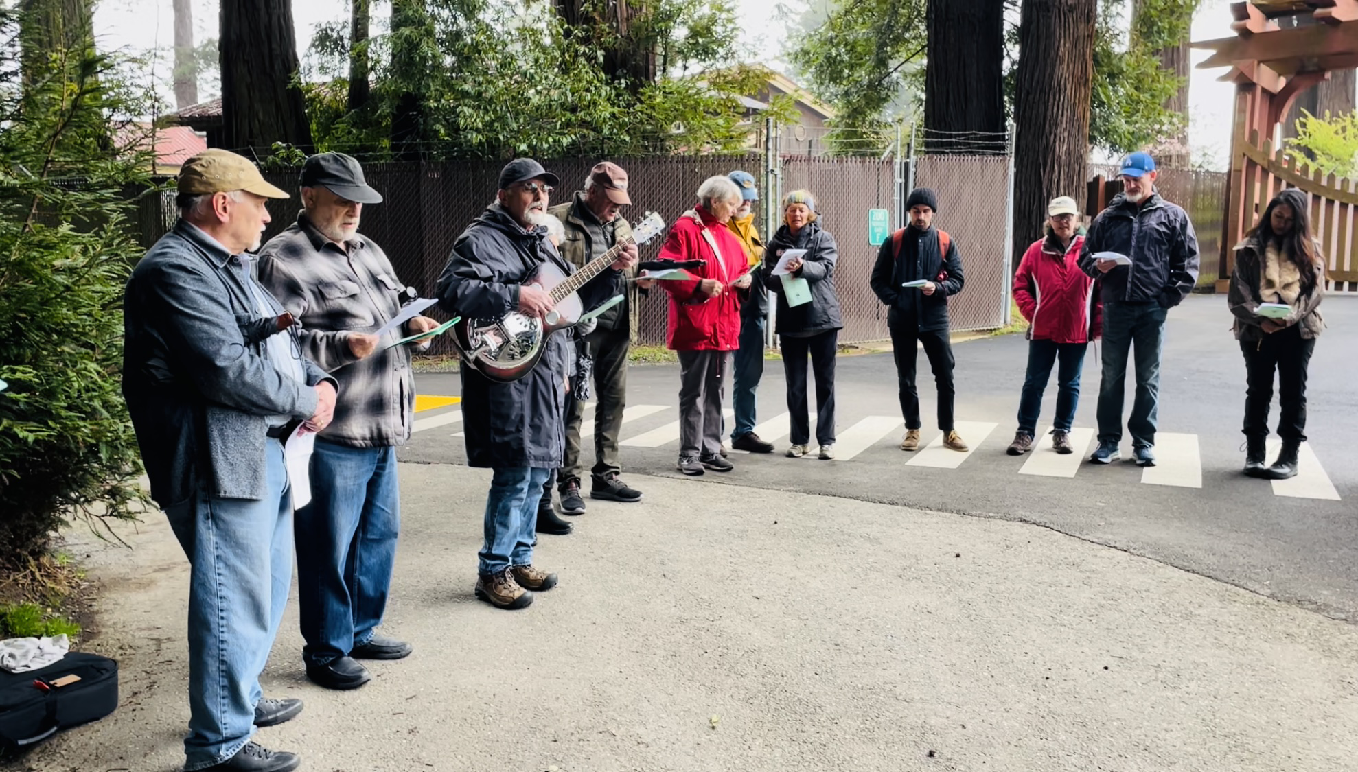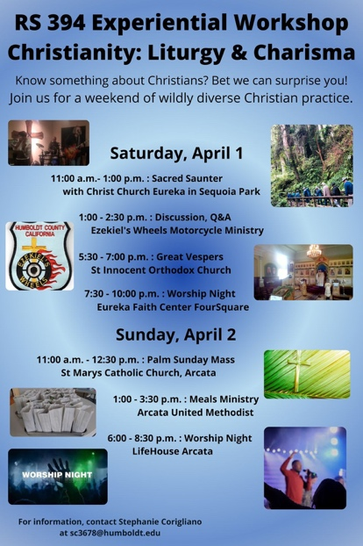

- Due to unfortunate timing, my CALL course on The Sensual Gospel of John: Experiencing the Fourth Gospel through the Five Senses began on Easter Monday this year, which meant I needed to prepare and record all my lectures during Holy Week. Fortunately, much of the content had already been prepared throughout Lent. My class includes 10 students, including Deacon Donna Arellano whom I previously taught at School for Deacons in Berkeley.

- Holy Week was both wonderful and exhausting; and I appreciated sharing a couple services with St. Francis (Tenebrae) and St. Alban’s (Maundy Thursday). Our Good Friday Solemn Liturgy service was well attended as was the Stations of the Cross Sacred Saunter. Our Holy Saturday Sacred Saunter included members from St. Francis, St. Alban’s, Grace Good Shepherd (Lutheran and Presbyterian), and the Church of Jesus Christ of Latter-day Saints. Although the Great Easter Vigil attendance was not high, it was also not low and everyone who participated experienced it as especially memorable. Finally, it was a joy and honor to baptize Isaac and Felix on Easter Sunday!

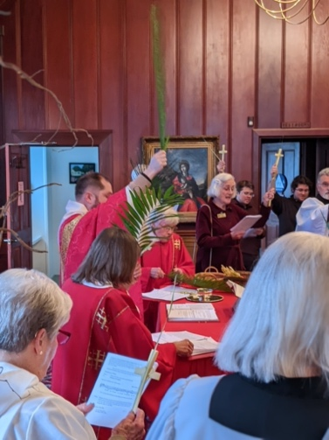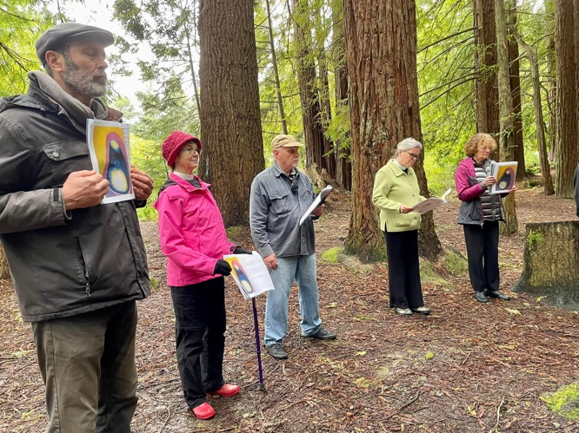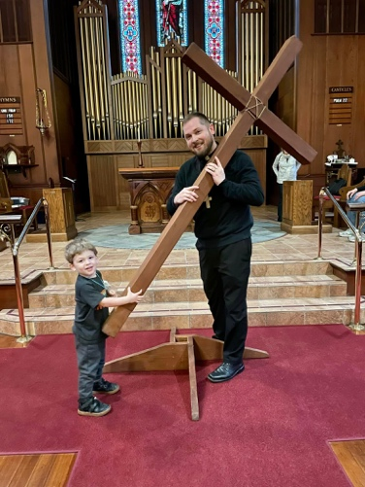

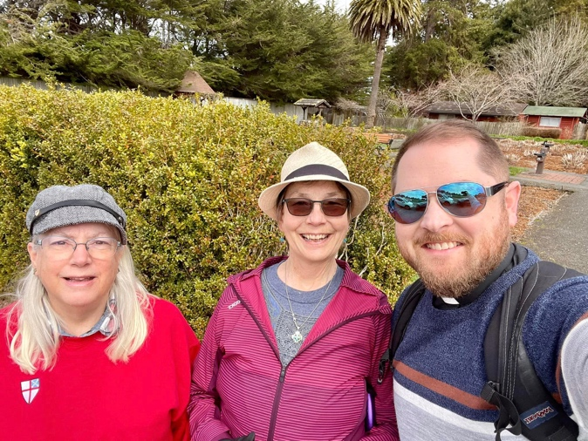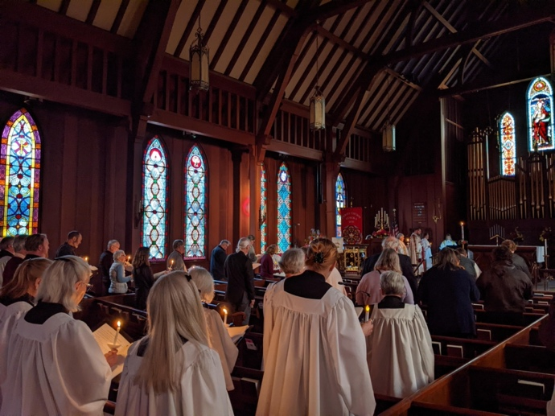

- On Wednesday April 12, I met with Pastor Jeri Gray-Reneberg to discuss her Letter of Agreement.

- On Thursday April 13, I emailed the co-authors of Changed in a Flash: One Woman’s Near-Death Experience and Why a Scholar Thinks it Empowers Us All. Elizabeth Krohn, whom I preached about on the Fifth Sunday in Lent as well as on Good Friday, wrote back the next day and said, “Wow! I love the synchronicities. I am so touched by your Good Friday sermon. I was crying as I watched it and recalled what a good friend John Price was to me…I am so happy to hear that our book impacted you in positive ways. It means so much to me that you took the time to write to us. I hope that perhaps someday we can meet in person.” This is yet another testimony to the significance and reach of our livestream ministry. Here’s the sermon in case you missed it: https://www.youtube.com/watch?v=9BlsK25KeOA

- On April 18, I was asked to write an endorsement for a book by Rabbi Anson Laytner titled Choosing Life After Tragedy, which will be published later this Spring. I met Anson Laytner while teaching a CALL course on Arguing with God.

